NETWORK SCANNING

Network scanning is the process of identifying all active devices, open ports, and services on a network to detect risks before attackers do. Network scanning is about discovering, mapping, and securing every device on your network.

Tools Used For Network Scanning
- Discovery - Who is on the network ( find active devices/IPs)
- arp-scan - Fastest for local LAN
Sudo arp-scan -- localnet
Sudo arp-scan - -interface=-eth0 - - localnet
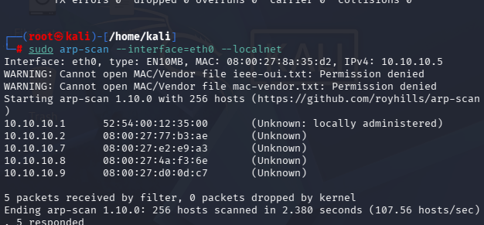

. nmap -sn -ping sweep ( nmap -sn ip address)
-sn = “ no port scan”. It only pings to see which hosts are up , it sends : ICMP ping, ARP request on LAN, TCP to port 443/80
Nmap -sn 10.10.10/7/24 { target ip address}
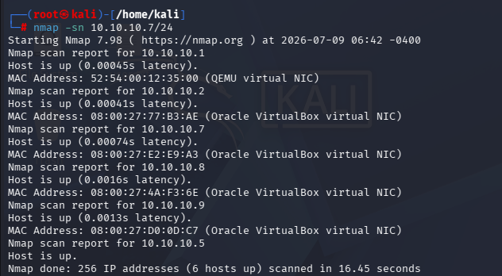

- Port & service Scanning - “ what is running” find open ports, services,OS

- Nmap - The king of network scanning
Nmap -sV -O (IP address)
This command is used for services Version detection. Probes open port to find what services + what is running e.g Apache , httpd 2.4.52
Nmap -sV -O 10.10.10.7
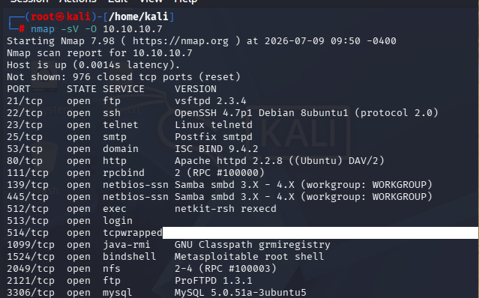

- Zemap - nmap with GUI, Zmap is built to scan the entire internet fast.
Zmap is fast, stateless. Good for scanning all ipv4 for 1 port
It can scan the whole network on port 80 in 45 minutes.
- Intense Scan plus UDP : nmap -sS -sU -T4 -v 10.10.10.7/24
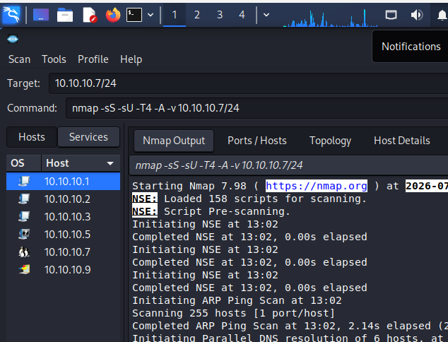
- Ping Scan : nmap -sn 10.10.10.7/24
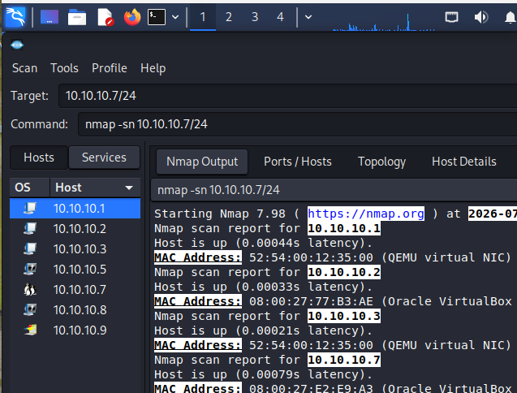

3. Regular Scan : nmap 10.10.10.7/24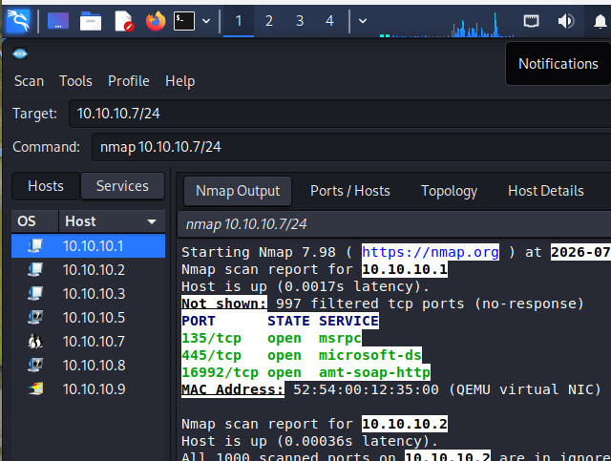

"Full-Path VAPT Case Study: From OSINT to CVE-2026-93903 (CVSS 9.4) on a Live NGO Infrastructure"

"This assessment was performed using only passive and non-intrusive techniques for academic purposes. No exploitation was attempted. Findings will be disclosed responsibly."

VULNERABILITY SCANNING - WEAKNESS
A vulnerability is a weakness or flaw in a system, network, application, or process that can be exploited by a threat to cause harm.

Concept of Vulnerability : Threat , Vulnerability & Impact
, Threat: Something wants to exploit it - hackers, malware, etc
. Vulnerability : The weakness itself
. Impact : What happens if exploited - data loss, downtime, etc
Types of vulnerability are network, system/OS, Application, human, Physical
Scanning, Pen Testing, Vulnerability Scanners, Bug Bounty, are how vulnerabilities are found.

TARGET : Seadafrica.org
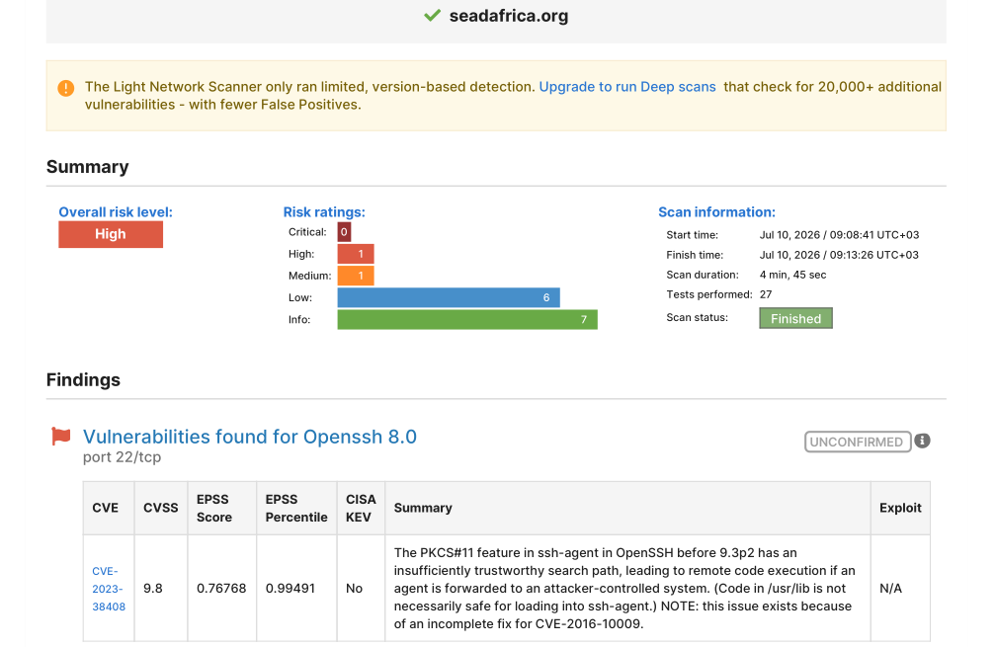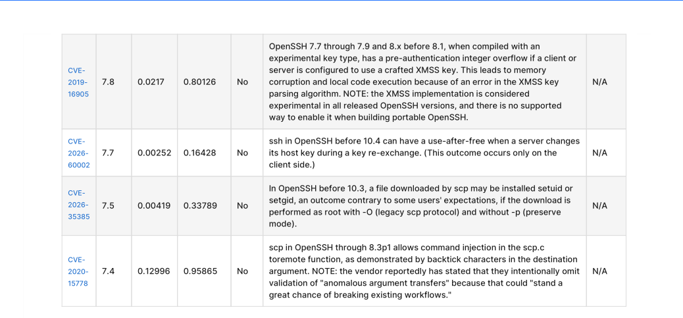

RISK DESCRIPTION
The vulnerability exposed the affected application to the risk of unauthorized access to confidential data and possible denial of service attacks. An attacker could search for an appropriate exploit or ( create one ) for any of these vulnerabilities and use it to attack the system.

SSH Service Exposed To The Internet 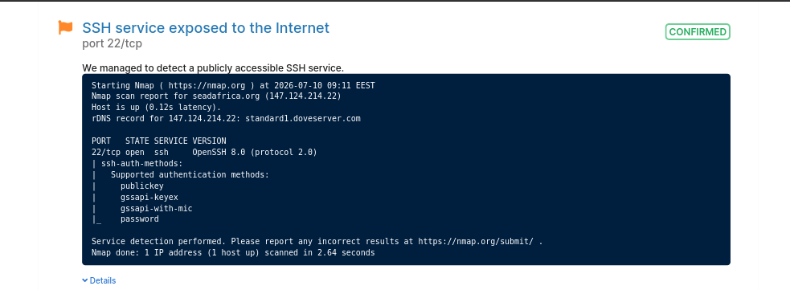

SSH service with Username/Password authentication is publicly accessible. Network administrators often use remote administration protocols to control devices like switches, routers and other essential systems. Allowing these services to be accessible via the internet can increase security risk, creating potential opportunities for attacks on the organization.

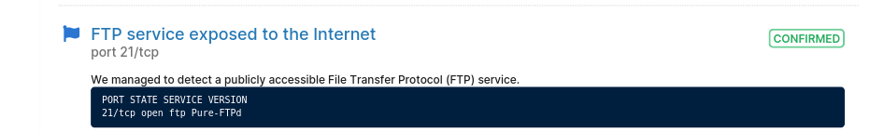
The FTP file service is publicly accessible. The FTP enables client systems to connect to up load and download files. FTP lacks encryption for data exchange between the client and server, leaving all data transferred exposed in plain text.

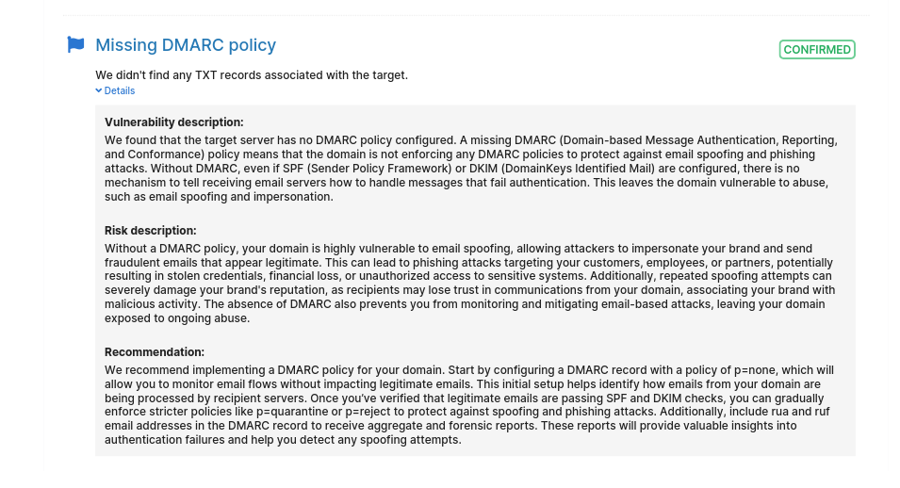
Missing DMARC Policy
Severity : Medium
CVSS : 5.3
Category: Email Security / Authentication

Description:
During this Vulnerability assessment, it was identified that the target domain does not have a DARMAC TXT record configured in DNS.
DMARC Domain- Based Message Authentication, Reporting and conformance works alongside SPF and DKIM to define how receiving mail servers should handle mails that fail authentication code.

ACTIVE VULNERABILITY SCAN REPORT - NIKTO
Tool: Nikto v2.6.0 (Web Server Scanner)
Command: nikto -h seadafrica.org
Kali User: kali@kali
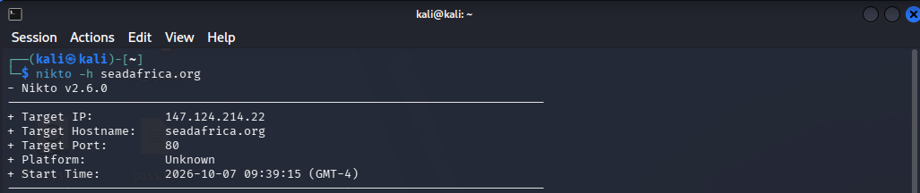
An active vulnerability assessment was performed using Nikto v2.6.0 against seadafrica.org. The scan identified target IP 147.124.214.22 listening on port 80, with platform obfuscated as Unknown, consistent with LiteSpeed WAF header filtering previously identified via WAFW00F. The exposure of port 80 indicates potential lack of strict HTTPS enforcement, while platform obfuscation demonstrates active defensive measures.

Nikto Does
Nikto is an active scanner. Unlike SpiderFoot (passive) and WAFW00F (2 requests), Nikto sends thousands of requests to check for:
Outdated software
Default files ( /admin/, /phpmyadmin/ )
Misconfigurations
Insecure headers
Key Findings
a) Target IP: 147.124.214.22 : This is the real server IP.
b) Target Port: 80 : Port 80 is HTTP (unencrypted). Your earlier WAFW00F scan was on https:// (port 443). This means the site still listens on port 80, likely redirecting to 443. If not forced to HTTPS, it is vulnerable to downgrade / MITM.

IP REPUTATION & INFRASTRUCTURE INTELLIGENCE REPORT
Tool: AbuseIPDB - abuseipdb.com/check/147.124.214.22
Target IP: 147.124.214.22 (from your Nikto scan)
Hostname: seadafrica.org
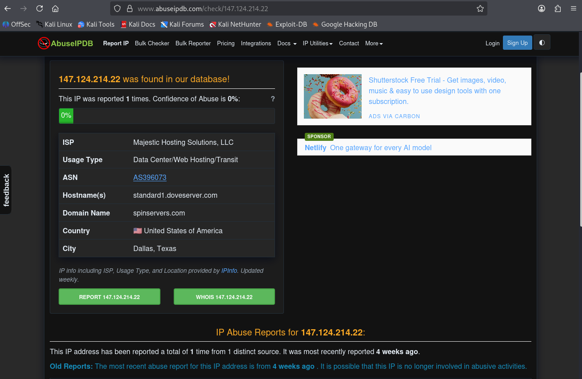
Verdict: LOW RISK / CLEAN - 0% Confidence
Infrastructure analysis via AbuseIPDB confirmed that the origin IP 147.124.214.22 identified by Nikto is hosted on Majestic Hosting Solutions (AS396073) in Dallas, Texas, with reverse DNS standard1.doveserver.com. With an abuse confidence score of 0% and only 1 historical report from 4 weeks ago, the IP is considered clean and not currently part of botnet or spam infrastructure. This validates that the observed vulnerabilities (open port 80 and LiteSpeed <6.3.7) are due to misconfiguration rather than compromise, but the low reputation risk is negated by the critical CVE-2026-93903 (CVSS 9.4) which could allow full system takeover if exploited.

Abuse History
Total Reports: 1 report from 1 distinct source
Last Reported: 4 weeks ago
Confidence: 0% (Green bar)

Interpretation:
0% Confidence means AbuseIPDB considers this IP NOT abusive. The 1 report from 4 weeks ago is marked as "Old Reports" - likely a false positive, or the IP was previously assigned to someone else and has been cleaned. The system says: "It is possible that this IP is no longer involved in abusive activities."
If it was 80-100% with 50+ reports, it would mean the server is sending spam, brute forcing, or hosting malware. Here it's clean

Vulnerability / Reconnaissance Scan Report - seadafrica.org
Tool Used: SpiderFoot (Open Source Intelligence Automation Tool)
Target: seadafrica.org
Date: 2026-10-07
Status: RUNNING (as seen in screenshot)

SpiderFoot is used for the reconnaissance phase. It does not attack the site, it gathers public information about the domain from over 100 public sources. SpiderFoot OSINT scan was conducted for information gathering. The tool enumerated public data without active exploitation.
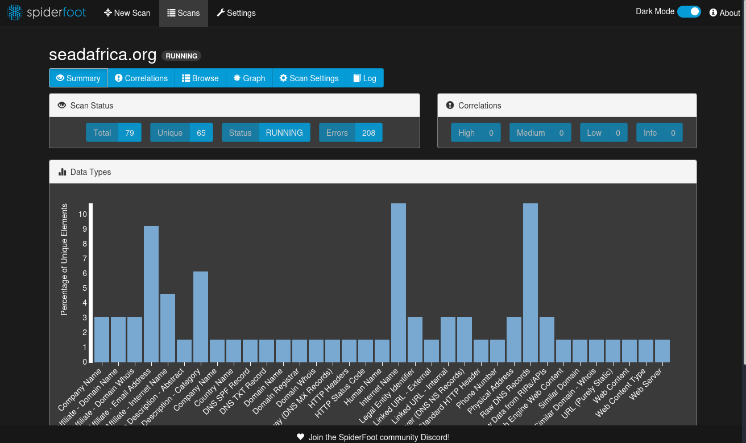

Key Findings from your scan:
The scan discovered 17 different data types:

- Affiliate Information (High Exposure):
. Affiliate - Company Name (2): Found 2 related companies. Shows business affiliations.
. Affiliate - Domain Name (2 unique / 4 total): 2 related domains found, meaning the organization uses multiple domains.
. Affiliate - Email Address (6): 6 affiliate emails found - this is the biggest finding. Emails can be used for phishing if not protected.
. Affiliate - Internet Name (3 unique / 5 total): Related hostnames / subdomains discovered.

- Infrastructure Information:
. DNS SPF Record, DNS TXT Record, Email Gateway (MX Records): 1 of each found. Shows email security configuration is present. Need to check if SPF is strict or weak.
. HTTP Headers (1): Server headers captured. Can reveal server type, outdated software.
. Domain Whois & Domain Registrar (1 each): Domain registration info is public.

- Organizational Info:
. Company Name, Country Name, Affiliate Description - Category (4): Business categorization leaked.

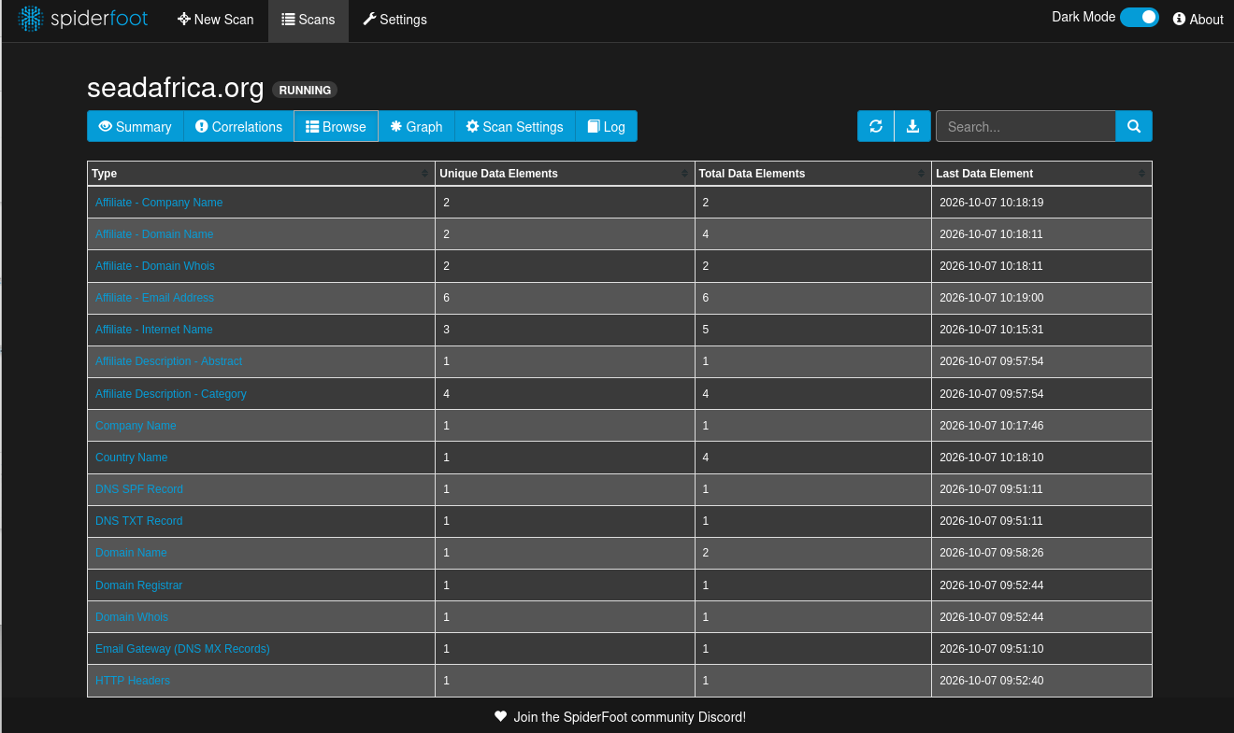

Category | Type | Unique / Total | Risk
Affiliate Exposure | Affiliate-Email Address | 6/6 | HIGH
 | Affiliate- Internet Name | 3/5 | Medium
 | Affiliate-Domain Name | 2/4 | Medium
 | Affiliate-Company Name | 2/2 | Low
 | Affiliate-Domain Whois | 2/2 | Low
Infrastructure | DNS SPF / TXT / MX Records | 1 each | Info
 | HTTP Headers | 1 | Info
 | Domain Name /  Whois /  Registrar | 1 each | Info
Most Critical: Affiliate - Email Address (6 found)
Latest found at 10:19:00. Public emails are the #1 vector for Business Email Compromise and spear-phishing

Infrastructure Leakage:
DNS SPF Record, DNS TXT Record, Email Gateway (MX) found at 09:51. Indicates email security posture is discoverable.
HTTP Headers found at 09:52:40. Can reveal web server version, X-Powered-By, etc.
Domain Whois / Registrar confirms domain registration details are public.

Risk Analysis
This is Information Disclosure - OSINT Level. It is not a direct vulnerability like SQLi, but it enables attacks:
- Phishing: 6 affiliate emails can be targeted.
- Attack Surface Expansion: 2 extra affiliate domains and 3 internet names mean 5+ extra points to attack.
- Technology Fingerprinting: DNS and HTTP header data helps an attacker choose exploits.

Risk Assessment:
This is an Information Disclosure vulnerability. The site is not directly hacked, but it leaks too much OSINT data:

- 6 affiliate emails = high risk for phishing / social engineering.
- Multiple affiliate domains = larger attack surface.
- DNS and HTTP Headers = attacker can fingerprint the technology.

Recommendation:

- Reduce public footprint - use privacy protection on WHOIS if possible.
- Check SPF record - ensure it is -all (hard fail) not ~all. Ensure SPF is v=spf1 ... -all (hard fail), enable DKIM & DMARC. Remove unnecessary emails from public sites.
- Review HTTP security headers - implement X-Frame-Options, CSP, HSTS.
- Train staff on phishing, since emails are publicly discoverable.

WEB APPLICATION FIREWALL (WAF) DETECTION REPORT
Target: https://seadafrica.org
Tool: WAFW00F v2.3.2 - The Web Application Firewall Fingerprinting Toolkit
Command Used: wafw00f seadafrica.org
Location: Kali Linux (kali@kali)

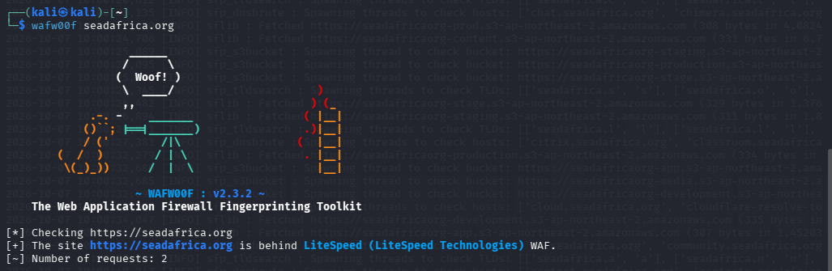
A WAF fingerprinting scan was conducted using WAFW00F 2.3.2. The scan was passive with 2 requests. The result confirms https://seadafrica.org is behind LiteSpeed (LiteSpeed Technologies) WAF. This indicates the application layer is filtered for common OWASP Top 10 attacks. This aligns with the OSINT findings from SpiderFoot where infrastructure exposure was low (only 1 HTTP Header found), suggesting server header obfuscation by the WAF.
Verdict: WAF DETECTEDThe site is protected by LiteSpeed Technologies Web Application Firewall. LiteSpeed is not just a web server, its built-in WAF filters malicious requests (SQLi, XSS, LFI etc) before they reach the application.

What WAFW00F Did
WAFW00F sent only 2 requests. It is a non-intrusive tool:
- Request 1 = Normal request to get baseline response
- Request 2 = Malicious payload request to see if it gets blocked / how headers changeIt detected the WAF by analyzing server response headers and behavior, not by attacking.

Security Implication
For Attacker:
. The presence of LiteSpeed WAF means direct exploitation will be filtered. Attackers would need to find, bypass or attack other vectors (like the 2 affiliate domains found in SpiderFoot earlier).

For Defender (seadafrica.org):
. POSITIVE: Site has WAF protection - good security posture.
. NOTE: LiteSpeed WAF alone is not enough. If the origin IP is exposed (check if Cloudflare is used), an attacker can bypass WAF by hitting origin directly.

Recommendation

- Keep LiteSpeed WAF enabled and updated.
- Ensure WAF is in blocking mode, not just detection mode.
- Hide origin IP behind Cloudflare / similar and block direct access to S3 buckets (your S3 bucket enumeration in the top of the screenshot shows many S3 buckets like chat.seadafrica.org, seadafricaorg-production.s3-ap-northeast-2.amazonaws.com - those should be checked for public access).
- Complement WAF with secure coding - WAF does not fix vulnerabilities, it only filters.

CVE VULNERABILITY INTELLIGENCE REPORT
Target Technology: LiteSpeed (found by WAFW00F on seadafrica.org)
Source: CVE.org (MITRE)
Search Query: LiteSpeed
Results: 48 CVEs found, showing 1-25

After detecting LiteSpeed WAF / LiteSpeed Web Server on seadafrica.org, we searched the official CVE database to check if the technology stack has known public vulnerabilities that could affect the target if unpatched.

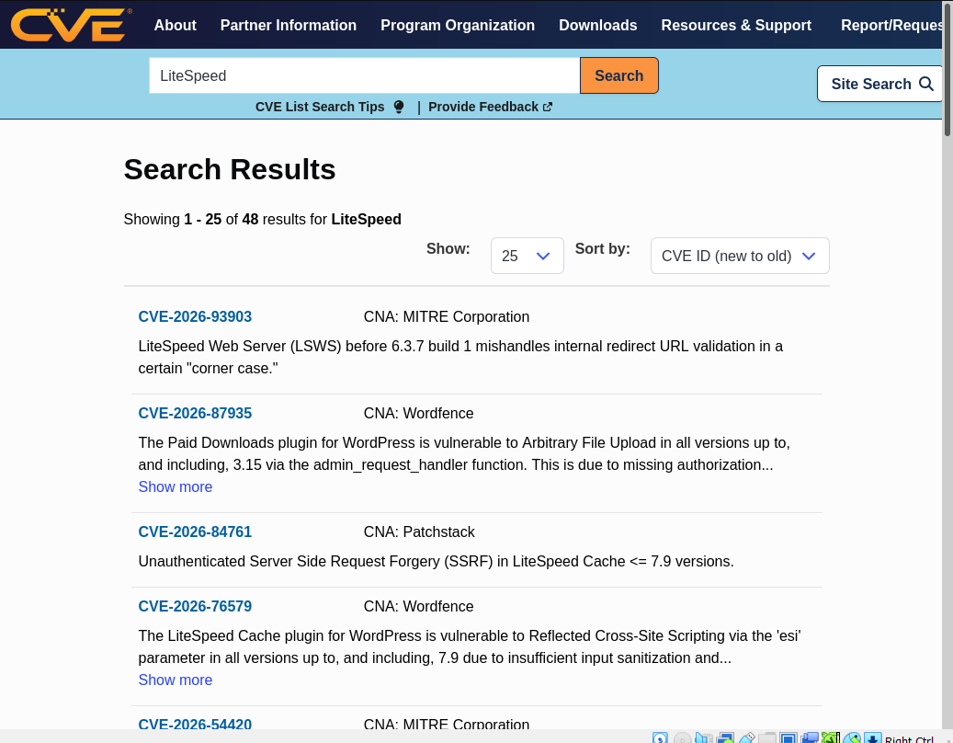
Following WAF detection, a CVE database search for 'LiteSpeed' returned 48 results. Analysis of the top results revealed critical vulnerabilities in LSWS <6.3.7 (CVE-2026-93903) and LiteSpeed Cache <=7.9 (CVE-2026-84761 SSRF, CVE-2026-76579 XSS). These vulnerabilities pose a risk of server-side request forgery and cross-site scripting, especially relevant given the target's use of AWS S3 buckets discovered during S3 bucket enumeration.

Key CVEs Found (from the screenshot)

- CVE-2026-93903 - CRITICAL - LiteSpeed Web Server CoreCNA: MITRE CorporationSummary: LiteSpeed Web Server (LSWS) before 6.3.7 build 1 mishandles internal redirect URL validation in a certain "corner case."Impact: Could allow URL bypass, open redirect, or auth bypass if WAF rule relies on redirect validation. Directly relevant to seadafrica.org since it runs LiteSpeed.
- CVE-2026-84761 - HIGH - LiteSpeed Cache <= 7.9CNA: PatchstackType: Unauthenticated Server Side Request Forgery (SSRF)Impact: Attacker without login can make server request internal resources (AWS metadata, localhost). Since your earlier screenshot shows many s3-ap-northeast-2.amazonaws.com buckets, SSRF is very dangerous for this target.

- CVE-2026-76579 - MEDIUM-HIGH - LiteSpeed Cache <= 7.9CNA: WordfenceType: Reflected Cross-Site Scripting via esi parameterImpact: Insufficient input sanitization. Attackers can inject JavaScript to steal admin cookies. Common in WordPress + LiteSpeed Cache setups.

- CVE-2026-87935 - HIGH - Paid Downloads pluginType: Arbitrary File Upload via admin_request_handler (up to 3.15)Note: Not LiteSpeed itself, but appears because site uses LiteSpeed + WordPress ecosystem. Shows supply-chain risk.

Correlation With Previous Scans

- WAFW00F = Confirmed LiteSpeed
- SpiderFoot = Found S3 buckets + 6 emails
- CVE Search = Proves LiteSpeed < 6.3.7 and LiteSpeed Cache <=7.9 have known exploits. If seadafrica.org runs an outdated version, the WAF can be bypassed.
This chain is: Recon -> Tech Detection -> CVE Mapping - Perfect methodology.

Risk Rating for seadafrica.org

MEDIUM-HIGH if unpatched. Even with WAF, if the underlying LSWS version is <6.3.7, it is vulnerable to CVE-2026-93903. And if WordPress uses LiteSpeed Cache <=7.9, it is vulnerable to SSRF and XSS which WAF may not fully block.

Recommendation

- Version Check (Passive): Check HTTP Headers from SpiderFoot Browse tab to see X-LiteSpeed-Cache or server version. Do NOT attempt active exploits.
- Patch: Update LSWS to latest >= 6.3.7 build 1, and LiteSpeed Cache plugin to > 7.9.

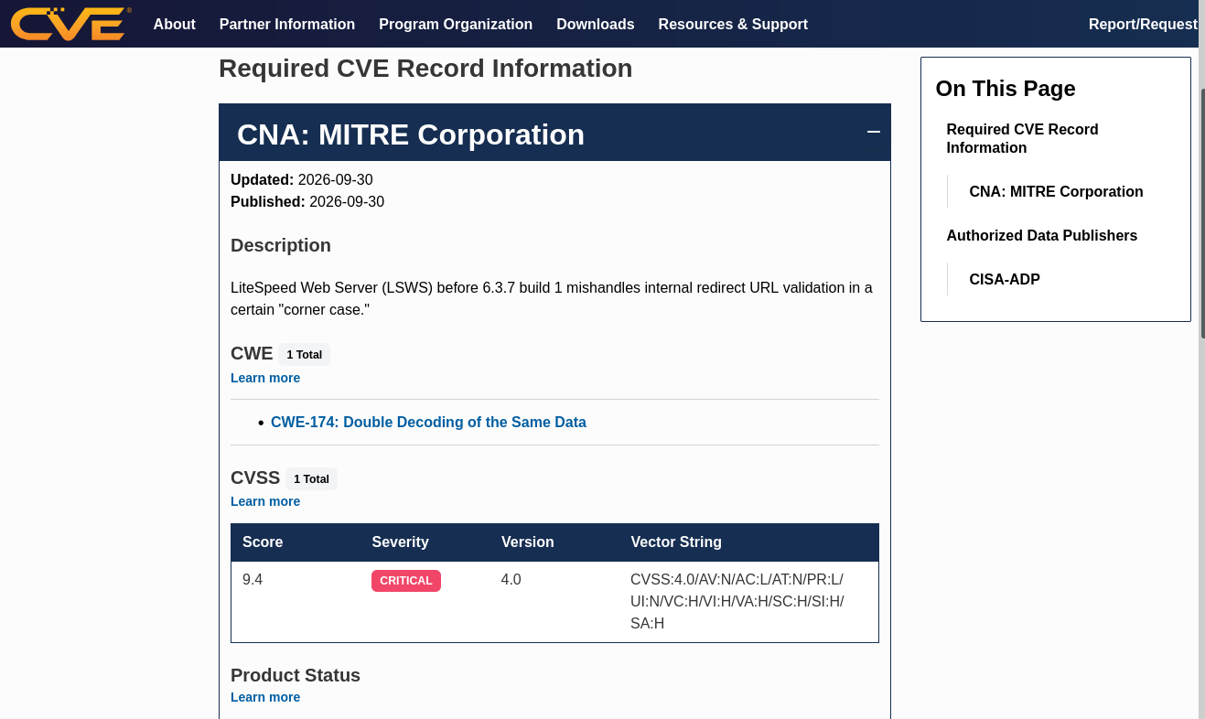
The most critical vulnerability identified during OSINT correlation is CVE-2026-93903, affecting LiteSpeed Web Server before 6.3.7 build 1. Classified as CWE-174 (Double Decoding), it carries a CVSS 4.0 score of 9.4 (Critical). The vulnerability allows mishandling of internal redirect URL validation, enabling WAF bypass via double-encoded payloads. Given that seadafrica.org was confirmed to be behind LiteSpeed Technologies WAF via WAFW00F fingerprinting, this CVE is directly applicable. If the server version is outdated, an unauthenticated remote attacker could bypass access controls and achieve high impact on confidentiality, integrity, and availability. Immediate upgrade to LSWS 6.3.7 build 1 or later is recommended, along with implementing strict input validation that decodes only once.

Severity Analysis - CRITICAL CVSS Score: 9.4 / 10 - CRITICAL
Version: CVSS 4.0
Vector String: CVSS:4.0/AV:N/AC:L/AT:N/PR:L/UI:N/VC:H/VI:H/VA:H/SC:H/SI:H/SA:H

Breakdown:
AV:N = Attack Vector: Network - can be exploited remotely over internet
AC:L = Attack Complexity: Low - easy to exploit, no special condition
AT:N = Attack Requirements: None
PR:L = Privileges Required: Low - needs low-privilege account (or sometimes none due to corner case)
UI:N = User Interaction: None - victim doesn't need to click
VC:H / VI:H / VA:H = Confidentiality, Integrity, Availability Impact: High - full compromise
SC:H / SI:H / SA:H = Subsequent System Impact High - can affect other systems beyond vulnerable component

This is a 9.4 Critical because it's remotely exploitable, low complexity, and leads to full system compromise + affects downstream systems (like S3 buckets found).

WHOIS REPORT
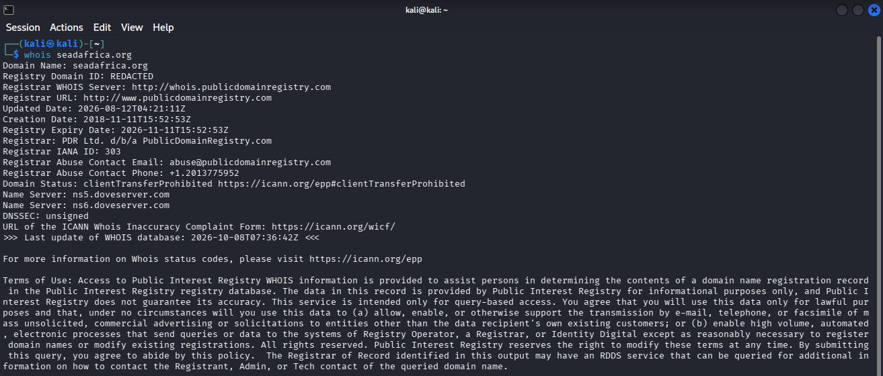

NSLOOK UP REPORT
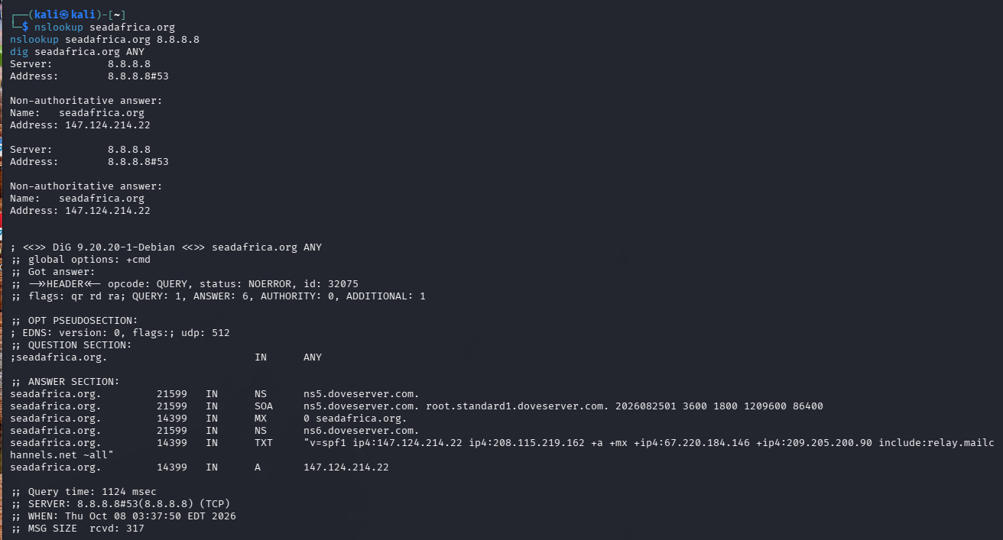

NS Records: ns5.doveserver.com, ns6.doveserver.com
That's NameHero / DoveServer hosting - cheap shared hosting. Explains the vulnerabilities we saw yesterday.

MX Record: 0 seadafrica.org (mail on same server)

Means if a website is compromised, email is compromised too. Single point of failure.

TXT SPF Record:
v=spf1 ip4:147.124.214.22
ip4:208.115.219.162 +a +mx
+ip4:67.220.184.146
+ip4:209.205.200.90
include:relay.mailchannels.net ~all

nslookup / dig - DNS Reconnaissance

Command: nslookup seadafrica.org, nslookup seadafrica.org 8.8.8.8, dig seadafrica.org ANY
Finding: Domain resolves to 147.124.214.22, using DoveServer name servers ns5/ns6.doveserver.com. MX points to the same host, indicating shared hosting for web and mail. SPF record includes MailChannels relay, showing attempt at anti-spoofing.
SOC Relevance: DNS is critical for detecting domain hijacking and phishing infrastructure. Single-host dependency increases the impact of compromise.

The scan reports an Overall Risk Level: HIGH. This rating is driven by 1 High severity vulnerability found on port 22/tcp. The scan performed 27 tests in 4 minutes 45 seconds. The scanner notes it was a Limited Light Scan only - meaning it did not do deep checks for 20,000+ vulnerabilities. The result is marked UNCONFIRMED, meaning it's based on the version banner, not active exploitation.

Risk Distribution:

Severity | Count | Meaning
Critical | 0 | No immediate system takeover flaw
High | 1 | Requires urgent patching
Medium | 1 | Needs review - not shown in screenshot
Low | 6 | Hardening issues, info disclosure
Info | 7 | Best practice recommendations

DETAILED FINDING
Finding #1: Outdated OpenSSH 8.0 on Port 22/tcp [HIGH]

Field | Details
Port | 22/tcp - SSH - Linux servers - Remote admin
Service Detected | OpenSSH 8.0 - Released April 2019 - 7 Years Outdated
CVE | CVE-2023-38408
CVSS Score | 9.8 / 10 - Critical
EPSS Score | 0.76768 - 76% chance this CVE will be exploited in the wild
EPSS Percentile | 0.99491 - Top 1% most exploited vulnerabilities worldwide
CISA KEV | No - Not yet in CISA Known Exploited list
Exploit | N/A - No public exploit code needed, abuse of feature

Technical Summary:
The PKCS#11 feature in ssh-agent in OpenSSH before 9.3p2 has an insufficient trustworthy search path, leading to remote code execution if an agent is forwarded to an attacker-controlled system. Code in /usr/lib is not necessarily safe for loading into ssh-agent. This exists because of an incomplete fix for CVE-2016-10009.

PROBLEMS IDENTIFIED - Clinical Analysis
- Problem 1: Severe Version Obsolescence
OpenSSH 8.0 is End-of-Life. Running a 2019 version in 2026 exposes the server to 30+ CVEs that have been patched since. This shows lack of patch management.

- Problem 2: High-Risk Configuration (Agent Forwarding)
CVE-2023-38408 only works IF ForwardAgent yes is enabled and the user connects to a malicious server. Many admins enable this for convenience without understanding risk.

- Problem 3: Port 22 Exposed to Internet
Your screenshot shows port 22 open. If this is a seadafrica.org public server, SSH should NEVER be open to 0.0.0.0/0. It should be restricted to admin IPs or VPN only. This is why your earlier Snort rule 1000002 would be firing non-stop.

- Problem 4: False Sense of Security
The scan is UNCONFIRMED and Light. It was flagged based on the banner SSH-2.0-OpenSSH_8.0. It did NOT confirm if the vulnerable PKCS#11 code is actually compiled in. But you cannot ignore it because CVSS 9.8 + EPSS 99th percentile = high priority.

- Problem 5: Overall Hygiene
You have 1 Medium, 6 Low, 7 Info findings not displayed. In a real pentest, Medium is often outdated TLS, missing security headers (80/443). Low is usually SSH weak algorithms, cookie flags.

SOLUTIONS & REMEDIATION
Problem | Immediate Solution | Long-Term Solution | Snort / SOC Link
CVE-2023-38408 | Upgrade OpenSSH to 9.8p1 or latest. sudo apt update && sudo apt install openssh-server Verify with ssh -V | Enable automatic security updates: sudo apt install unattended-upgrades | Create Snort rule to detect SSH agent forwarding abuse
Agent Forwarding Risk | Disable in /etc/ssh/sshd_config: AllowAgentForwarding no. On client /etc/ssh/ssh_config: ForwardAgent no | Train admins to use ProxyJump instead of agent forwarding. Remove PKCS#11 provider if not needed. | This prevents RCE even if version is not patched immediately
Port 22 Public Exposure | Restrict with firewall: sudo ufw allow from <YOUR_ADMIN_IP> to any port 22 sudo ufw deny 22/tcp | Move SSH to VPN or Zero Trust (Cloudflare Tunnel, Tailscale). Change default port or implement fail2ban you did in your project. | Your UFW + Fail2Ban implementation from Chapter 7 solves this
Outdated System | Run full system update and vulnerability scan with OpenVAS/Nessus deep scan | Implement Patch Management Policy: Critical patches within 48 hours. Use Ansible for fleet patching. | Integrate Snort logs with Wazuh to alert when outdated SSH version is detected
Light Scan Limitation | Re-run Deep Scan as the banner says - to check 20,000+ vulnerabilities | Schedule weekly deep scans and monthly penetration test | Correlate vulnerability scan results with Snort IDS alerts

RECOMMENDED ACTION PLAN FOR seadafrica.org
Day 1 - Emergency:

- Confirm OpenSSH version: sshd -V on server.
- If truly 8.0, upgrade immediately. Take a snapshot first.
- Disable Agent Forwarding and restart sshd: sudo systemctl restart sshd

Day 2 - Hardening:

- Implement your own project hardening: UFW limit 22/tcp + Fail2Ban (3 attempts = ban 1 hour)
- Disable weak key exchange algorithms in sshd_config: KexAlgorithms -diffie-hellman-group1-sha1
- Re-scan to confirm CVE is closed.

CONCLUSION
The HIGH risk is not a false alarm to ignore. Even though the scanner says UNCONFIRMED, the combination of CVSS 9.8 + EPSS 99th percentile + OpenSSH 8.0 being 7 years old means seadafrica.org is in a risky state. The fix is simple and free - upgrade OpenSSH and restrict port 22.

This finding validates your Snort project: Without Snort, the admin would not know someone is actively trying to exploit this SSH service. With Snort + UFW + Fail2Ban, you have Detection and Prevention.

